

**FPT ACADEMY INTERNATIONAL**

**FPT – APTECH COMPUTER EDUCATION**

**Centre Name: ACE-HCM-2FPT**

**Address: 275 Nguyen Van Dau, Binh Thanh District, Ho Chi Minh City, Viet Nam**

**Papyrus Limited**

|  |  |  |
| --- | --- | --- |
| **Supervisor.** | Mr. Nguyen Phat Tai | |
| **Batch.** |  | |
| **Group.** | Group 1 | |
| **Serial No.** | **Enrollment Number** | **Student Name** |
| 1. | Student1387810 | Nguyen Ngoc Bao Duy |
| 2. | Student1387838 | Le Duc Anh |
| 3. | Student1387799 | Bui Nguyen Hai Tri |

Sep 15th, 2022

**This is to certify that**

**MR:**

* Nguyen Ngoc Bao Duy
* Le Duc Anh
* Bui Nguyen Hai Tri

**Has successfully design & developed**

E-Project: Papyrus Limited

**Submitted by: Nguyen Ngoc Bao Duy**

**Date of issue: Oct 15th, 2022**

**Authorized Signature: Nguyen Ngoc Bao Duy**

***TABLE OF CONTENT***

ACKNOWLEDGEMENT4

SYNOSIS4

PROBLEM DEFINITION5

CUSTOMER’S REQUIREMENTS SPECIFICATION6

SCOPE OF THE WORK9

ARCHITECTURE AND DESIGN OF THE SYSTEM10

DIAGRAM OF THE WEBSITE………………………… ……………………………………11

TASK SHEET REVIEW 1……………..………………………………………………………12

SITE MAP………………………………………………………………………………………13

MOCK OF THE WEBSITE……………………………………………………………………14

TASK SHEET REVIEW 2……………………………………………………………………..20

WEBSITE DESCRIPTION....…………………………………………………………………21

SOURCE CODE...............……………………………………………………………………32

TASK SHEET REVIEW 3……………………………………………………………………..37

***ACKNOWLEGMENT***

On behalf of all the members of group 1, I would like to thank you all for the hard works, supports to make this eProject complete successfully. Especially, Mr. Nguyen Phat Tai, our teacher, he helped us a lot from the day that we started to study at FPT Aptech. With this eProject, he has guided us with his enthusiasm and rigorous, because of his guiding, we would be able to finish this project. Besides, I want to thank all the team member of group 1, each of the team members has been working continuously in 4 weeks in order to complete this project. Last but not least, we would like to say thank you to our family for always supporting us, creating the best conditions for us to focus on the project, and putting faith in the dreams we pursue.

***SYNOSIS***

Papyrus Limited is market leader in the social expression industry. It has grown from a cards-only company to a complete social expressions company. This Company has grown with the spread of modern culture, increasing urbanization and improving standard of living. Adorability and sentiment drive its brand appeal to all age groups and demographics. Papyrus has enormous ranges which have established exemplary mastery over its large network of distributors, retailers and franchisees.

In a short few years, Papyrus had become a recognized brand – and a household name. The Papyrus Gallery chain came next. This first-of-its kind concept-store and was an instant success. As the market environment continued to evolve and internet became an important aspect of urban life, Papyrus kept pace by introducing e-cards and offering online gifting opportunities through its e-commerce portal.

***PROBLEM DEFINITION***

The Web site is to be created based on the following requirements.

1. The Top of the Page should be presented with a suitable logo with images of cards.
2. The site should display a menu with various sections listed into it.
3. Various sections such as Birthday, Anniversary, Friendship, New Year, Mother’s Day etc. should be provided with listing of Cards and other Gift-Items.
4. Top Selling section should be provided with most selling items listed into it.
5. On Clicking on any Card or Gift-Item should open a pop-up window.
   * A brief summary about individual product should be displayed on the Popup window along with the price.
6. Filter should be provided to user to select product, brand etc.
7. User should be allowed to provide Ratings and Feedback.
8. Site map, Gallery, About us, Contact us link must be added.
9. About Us and Contact Us: This menu option should display Email id, address, and contact number.
10. Color combination must be uniform throughout the project.
11. Navigation must be smooth.

Over and above this, the portal should implement the following functionalities:

* Display a continuous scrolling ticker at the bottom of the page with current date, time, and location (hint: Use geolocation features of HTML5).
* Display a visitor count at the top right corner of the page beside a logo image.
* The menu options should change color on hover and also after clicking.
* Fade in and fade out options can be used for the menus.

***CUSTOMER’S REQUIREMENT SPECIFICATION (CRF)***

**Client: Papyrus Limited.**

**Business / Project Objective**

* The Objective of this program is to give a sample project to work on real life projects. These applications help you build a larger more robust application.
* The objective is not to teach you JavaScript/Dreamweaver but to provide you with a real life scenario and help you create basic applications using the tools.
* You can revise the chapters before you start with the project.
* This project is meant for students who have completed the module of ***HTML5***. These programs should be done in the Lab sessions with assistance of the faculty if required.
* It is very essential that a student has a clear understanding of the subject. Students should go through the project and solve the assignments as per requirements given.
* Kindly get back to [eprojects@aptech.ac.in](mailto:eprojects@aptech.ac.in) in case of any doubts regarding the application or its objectives.

**Input to the system:**

* Browsing products based on type of gift-items.
* Including detailed information of each products.

**Output from the system:**

* A menu that will categorize all the functions of the site.
* Display the list of available gift-item category wisely.
* Perform the search based on a particular: brands, products.
* Perform the search based on a particular: type of events (example: Birthday, Anniversary, Friendship, New Year, Mother’s Day…)
* The site should display a menu with various sections listed into it.
* Show the shopping location in the Contact Us page.
* Besides the above requirements, the site should have look and feel as per the industry standards.

**Expected delivery date:** October 15th, 2022

**List of deliverables:**

* Document Word
* User Guide
* Source Code
* Video Clip

**Hardware/Software Requirements:**

1. **For Developer**

Hardware

* Intel Core i3/i5 Processor or higher
* 8 GB RAM or above
* Color SVGA
* 500 GB Hard Disk space
* Mouse
* Keyboard

Software

Technologies to be used:

* Frontend: HTML5, CSS, Bootstrap, JavaScript, jQuery, AngularJS.
* Data Store: JSON files or TXT files

1. **For web user**

Hardware

* Intel Pentium 4 processor or higher
* 512 Megabytes of RAM of higher

Software

* Operating Portal: Windows
* Browsers: Edge, Chrome, Mozilla Firefox, Safari

***SCOPE OF THE WORK (IN BRIEF)***

After a long and detailed discussion, our group has decided to create a website contain the following webpages:

1. ***Home:*** Displays basic information about core values of Papyrus bringing to Customer throughs Slider, Banner, Brief Text.
2. ***Product:*** Displays all selling items.
3. ***Events:*** Displays list of events and relevant items.
4. ***Gallery:*** Displays all item collections.
5. ***Pages:***

***About us:*** Mentions about the information and development process of the company (and some big event we used to organize)

***Contact us:*** Displays information about company: founder, CEO, phone number, email, address.

***Site-map:*** showsPapyrus site-map.

**Privacy Policy:** showsPapyrus policy.

**Term&Condition:** Displays the terms, rules and guidelines for using our website.

**FAQS:** provides answers to a list of typical questions that users might ask regarding a particular subject.

1. **Log in:** This page allows users to log in to their account or create their own one through the account creation section.
2. **Cart:** This page allows users to review the selected products and then proceed the payment.

***ARCHITECTURE AND DESIGN OF THE SYSTEM***

Webpage request



Requested Page

**RENDERING**

**ENGINE**

**HTML5**

**CSS3**

**WEB SERVER**

**WEB BROWSER**

**CLIENT**

**SERVER**

***DIAGRAM OF THE WEBSITE***

HOME



EVENTS

GALLERY

PRODUCT

CART

LOG IN

PAGES:

- ABOUT US

- CONTACT US

- SITE-MAP

- PRIVACY POLICY

- TERM&CONDITION

- FAQS

***TASK SHEET REVIEW 1***

|  |  |  |  |  |  |  |  |
| --- | --- | --- | --- | --- | --- | --- | --- |
| **Project Ref. No.:**  **eP/Advertisement Portal Management System/01** | | **Project Title:** | **Activity Plan Prepared By:** | **Date of Preparation of Activity Plan:** | | | |
| **Sr.**  **No.** | **Task** | **Actual**  **Start Date** | **Actual Days** | **Team**  **Mate Names** | **Status** |
| 1 | Problem Statement | Papyrus Limited | Duy | 15-Sep-2022 | 1 | Duy, Anh, Trí | Completed |
| 2 | Analysis of requirements about the website | 15-Sep-2022 | 1 | Duy, Anh, Trí | Completed |
| 3 | The scope of the work (in brief) | 15-Sep-2022 | 1 | Duy, Anh, Trí | Completed |
| 4 | Architecture and design of the system | 15-Sep-2022 | 1 | Duy, Anh, Trí | Completed |
| 5 | Diagram of the website | 15-Sep-2022 | 1 | Duy, Anh, Trí | Completed |
| 6 | Home Page | 17-Sep-2021 | 1 | Duy, Anh, Trí | Completed |
| 7 | JSON Files | 17-Sep-2021 | 1 | Duy, Anh, Trí | Completed |
| 8 | Task Sheet | 17-Sep-2021 | 1 | Duy, Anh, Trí | Completed |

|  |  |
| --- | --- |
| **Date: 17 – Sep – 2022** | |
| Signature of Instructor:  **Mr. Nguyen Phat Tai** | Signature of Team Leader:  **Mr. Nguyen Ngoc Bao Duy** |

***SITE MAP***

***MOCK OF THE WEBSITE***

1. ***HOME***
2. ***PRODUCT***
3. ***EVENT***
4. ***GALLERY***
5. ***LOGIN***
6. ***SHOP CART***

***TASK SHEET REVIEW 2***

|  |  |  |  |  |  |  |  |
| --- | --- | --- | --- | --- | --- | --- | --- |
| **Project Ref. No.:**  **eP/Advertisement Portal Management System/01** | | **Project Title:** | **Activity Plan Prepared By:** | **Date of Preparation of Activity Plan:** | | | |
| **Sr.**  **No.** | **Task** | **Actual**  **Start Date** | **Actual Days** | **Team**  **Mate Names** | **Status** |
| 1 | Product, events, gallery, pages, login, cart pages | Papyrus Limited | Duy | 18-Sep-2022 | 1 | Duy, Anh, Trí | Completed |
| 2 | Read and updated json | 19-Sep-2022 | 1 | Duy, Anh, Trí | Completed |
| 3 | Made filter for product page | 20-Sep-2022 | 2 | Duy, Anh, Trí | Completed |
| 4 | Made filter for navbar | 25-Sep-2022 | 3 | Duy, Anh, Trí | Completed |
| 5 | Debug | 29-Sep-2022 | 4 | Duy, Anh, Trí | Completed |

|  |  |
| --- | --- |
| **Date: 29 – Sep – 2022** | |
| Signature of Instructor:  **Mr. Nguyen Phat Tai** | Signature of Team Leader:  **Mr. Nguyen Ngoc Bao Duy** |

***WEBSITE DESCRIPTION***

1. ***Home Page***

* Home page displays following information:
* Slide show
* Top selling products
* New products
* Footer that including links to other sites and scrolling ticker.
* Screenshot:

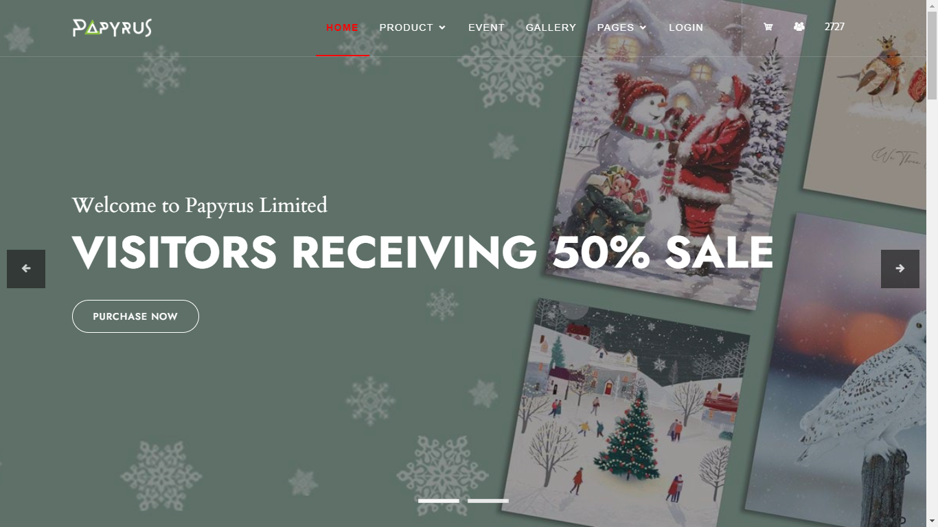

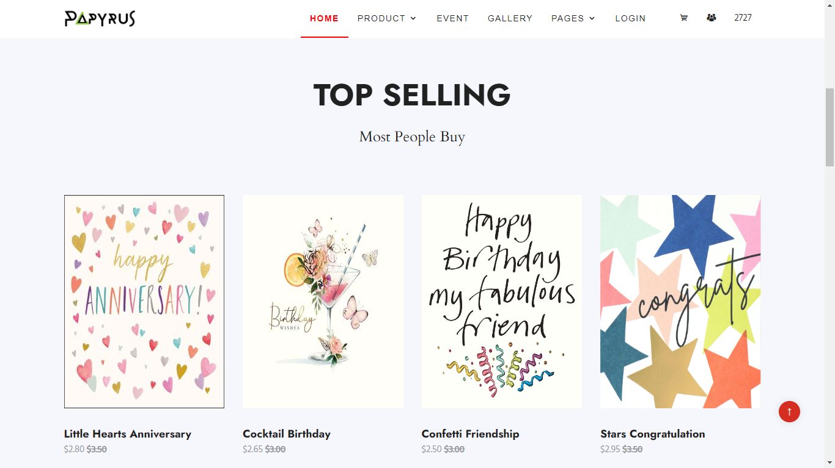

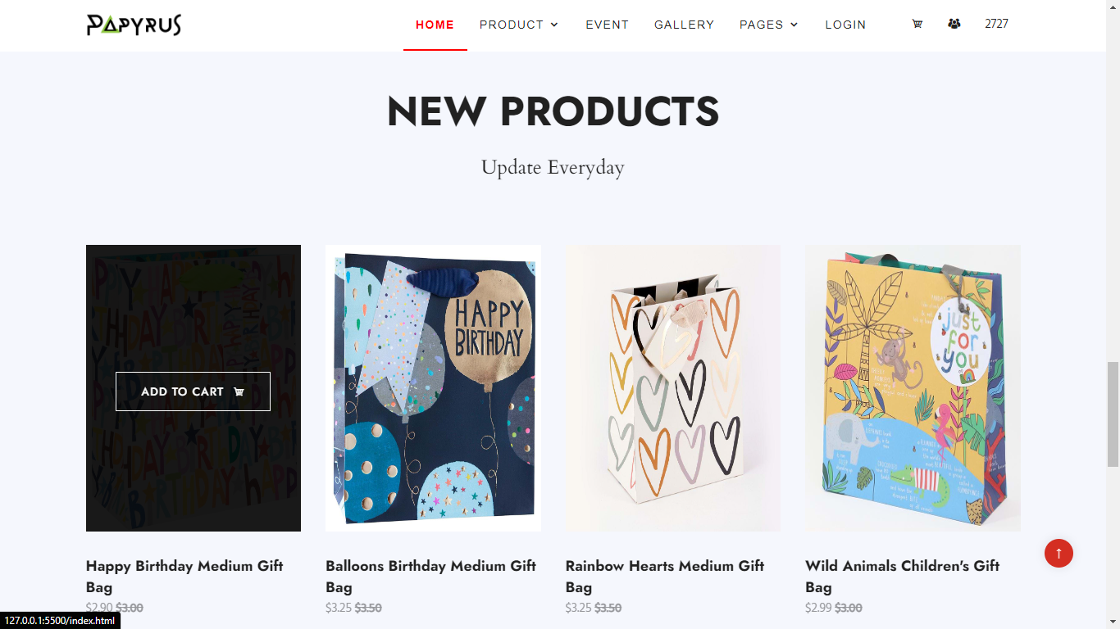

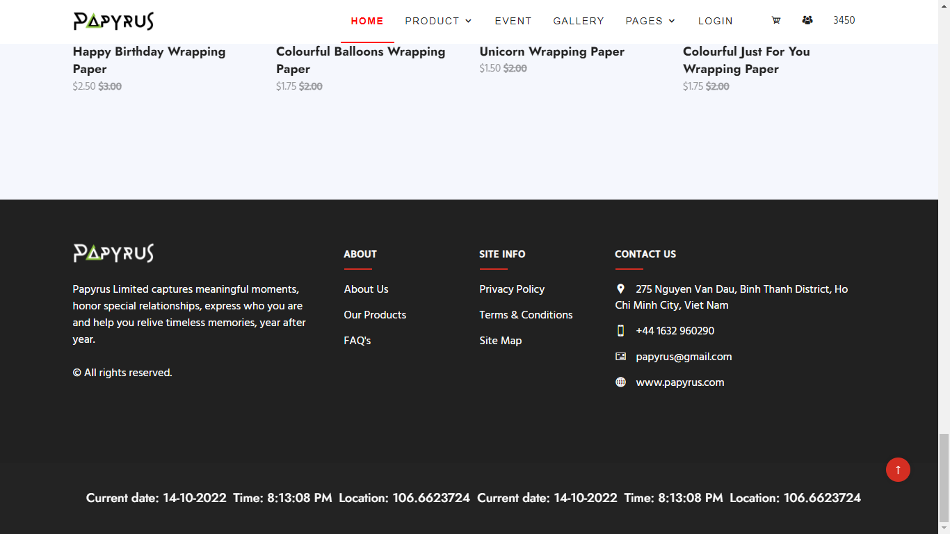

1. ***Product page***

* Description: this page contains various products with their information sorted by category, occasion or holiday. People can also search products by their names or prices and filter them. The detail of products will be shown when clicking on them. Products can be added to cart quickly by a click on the button of each pictures. When the customer clicks on the product title, the product's details page will appear for the user to read before deciding to buy.
* Screenshot:

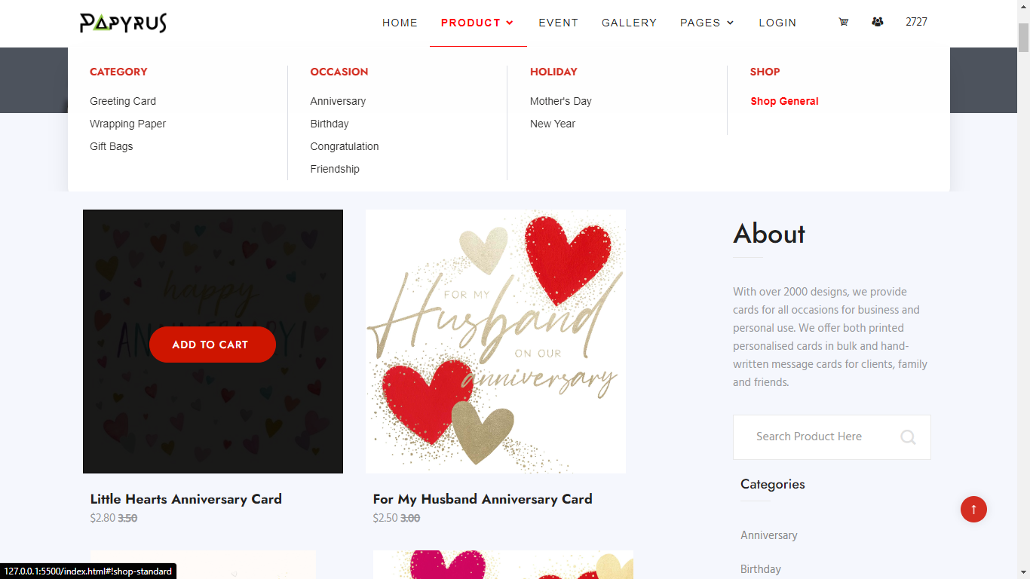

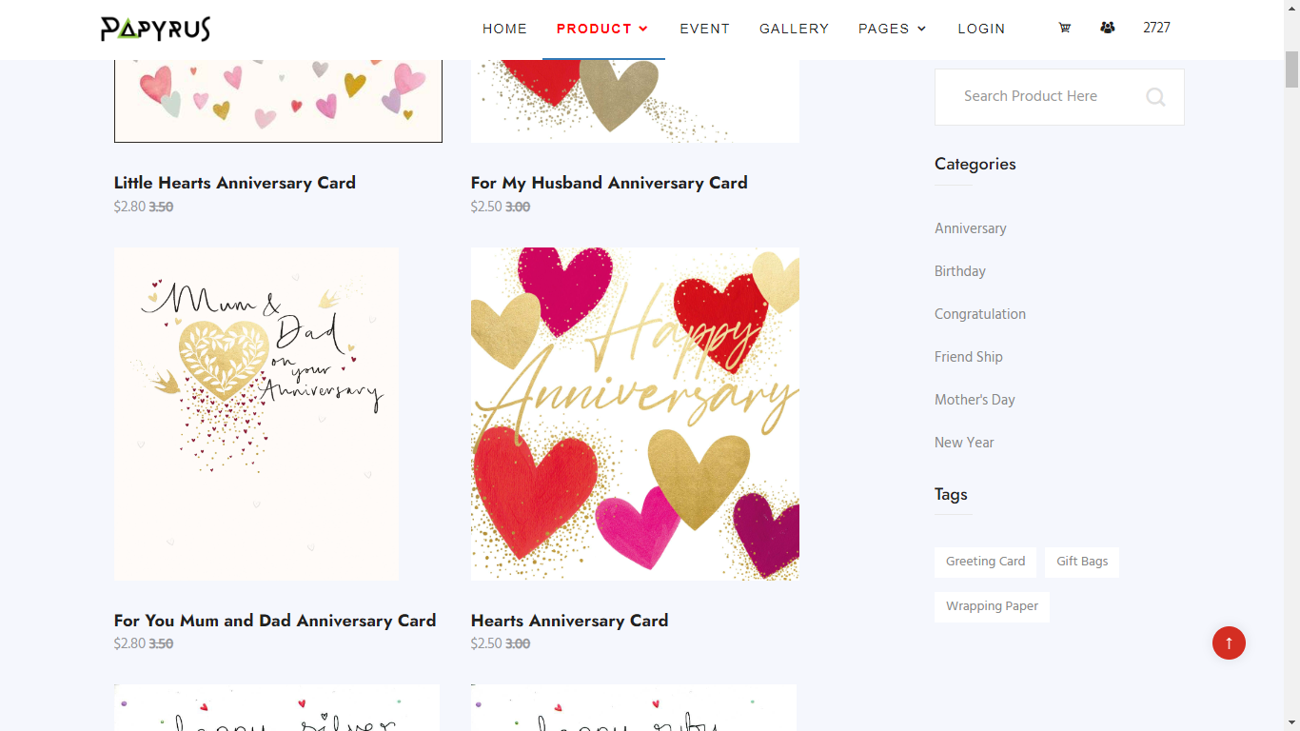

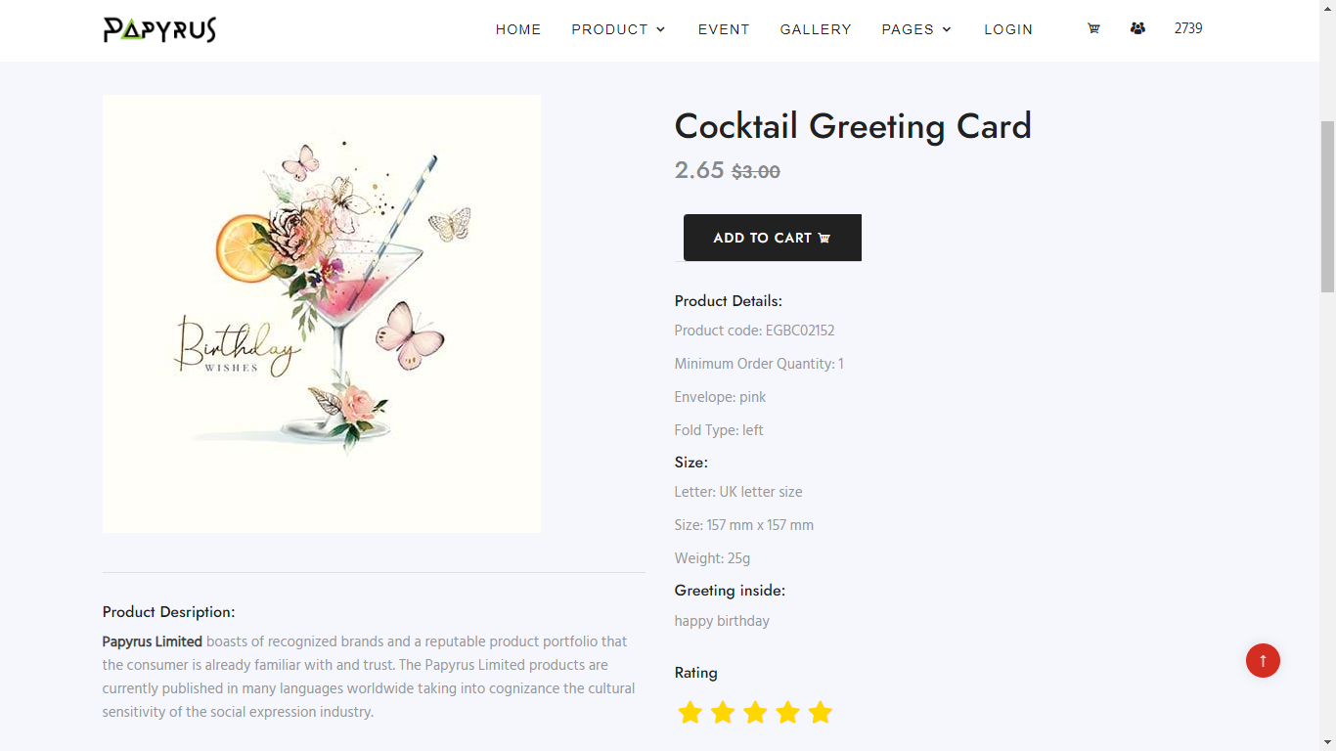

1. ***Cart Page***

* Description: This page displays information about the products that have been added to the cart including the product name, quantity, price and total amount.
* Screenshot:

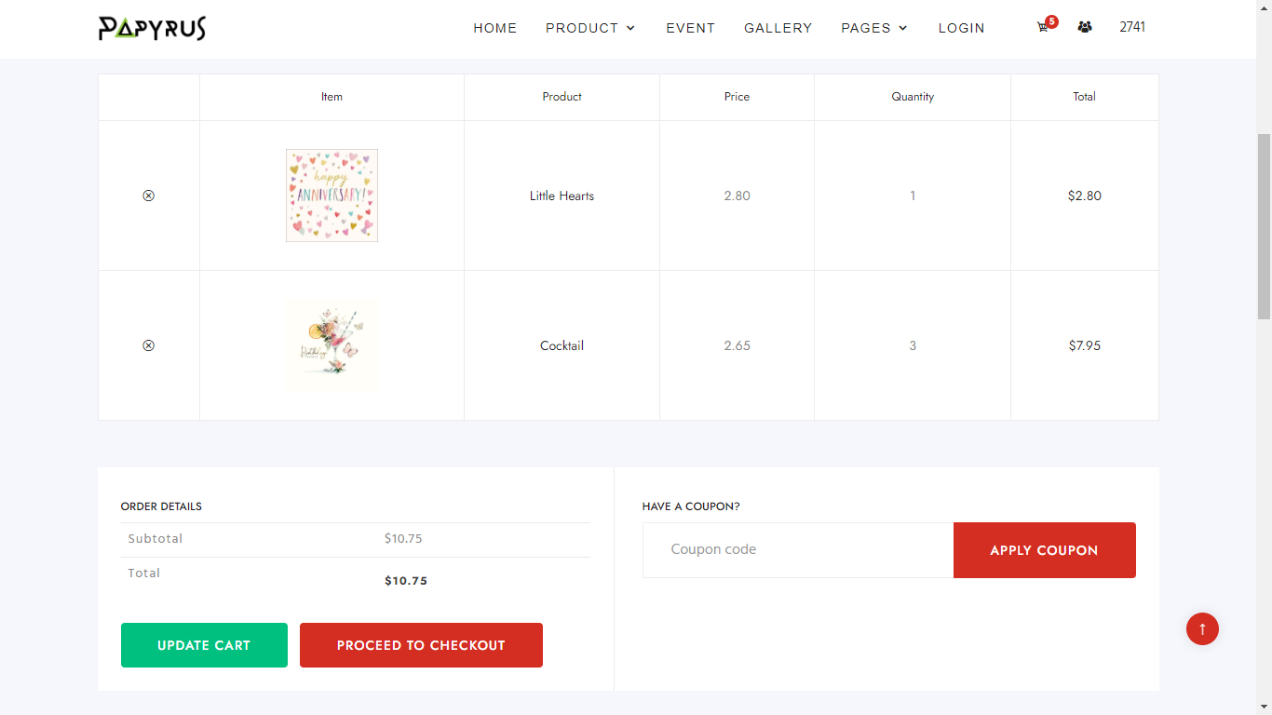

1. ***Event Page***

* Description: this page displays events where customers can find related products.
* Screenshot:

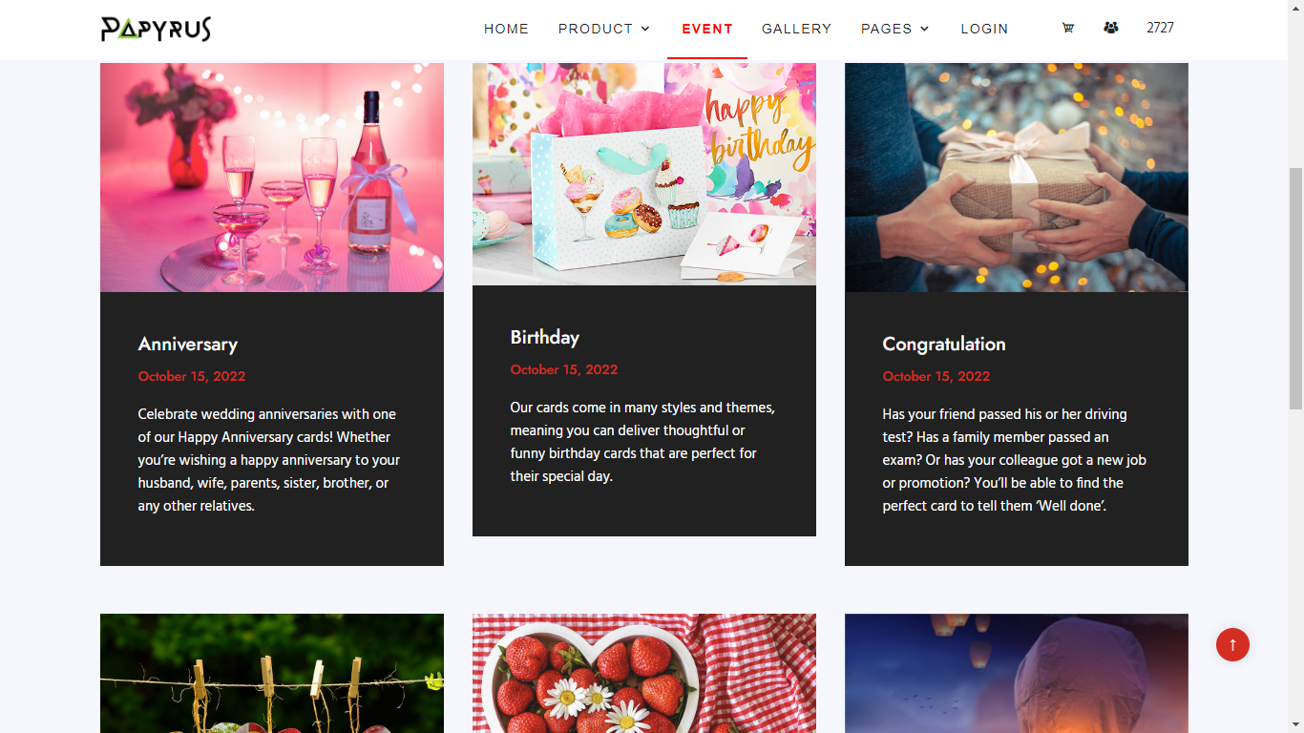

1. ***Gallery Page***

* Description: This page displays the pictures of the product. User can click on the photo to zoom-in.
* Sreenshot:

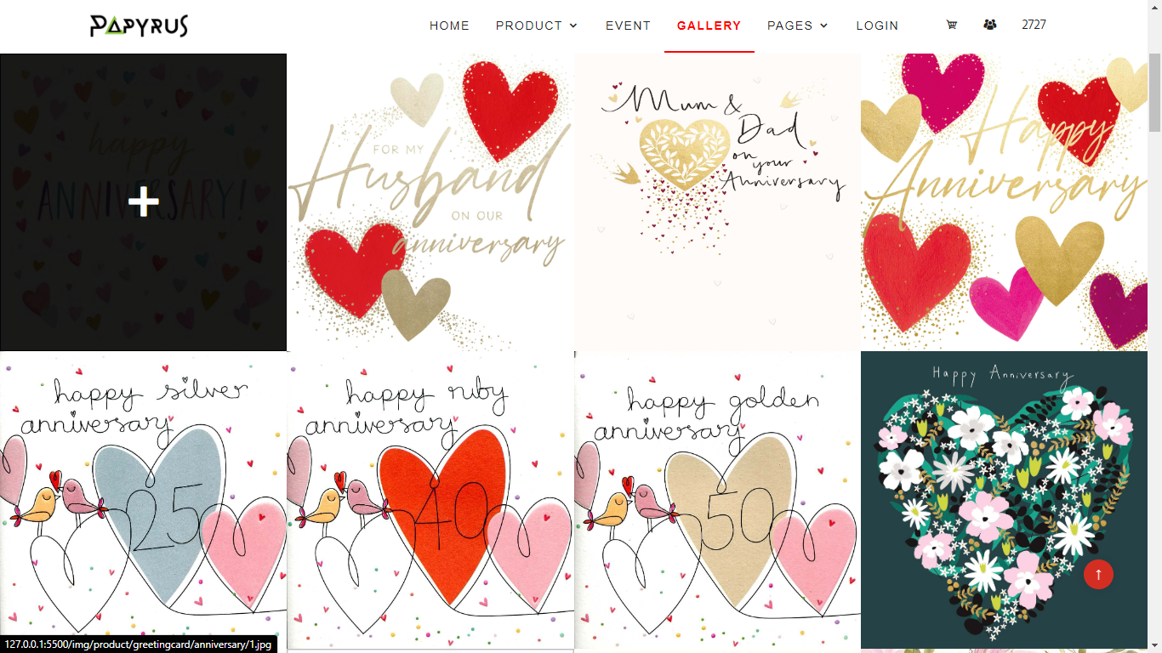

1. ***Pages***
   1. **About us Page**

* Description: This page displays information about the company's history, vision, mission, team members and loyal customers.
* Screenshot:

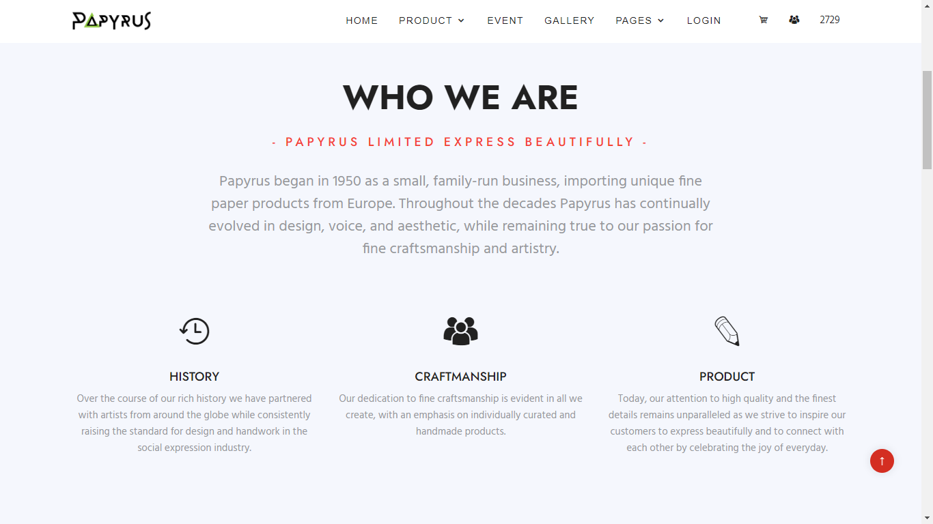

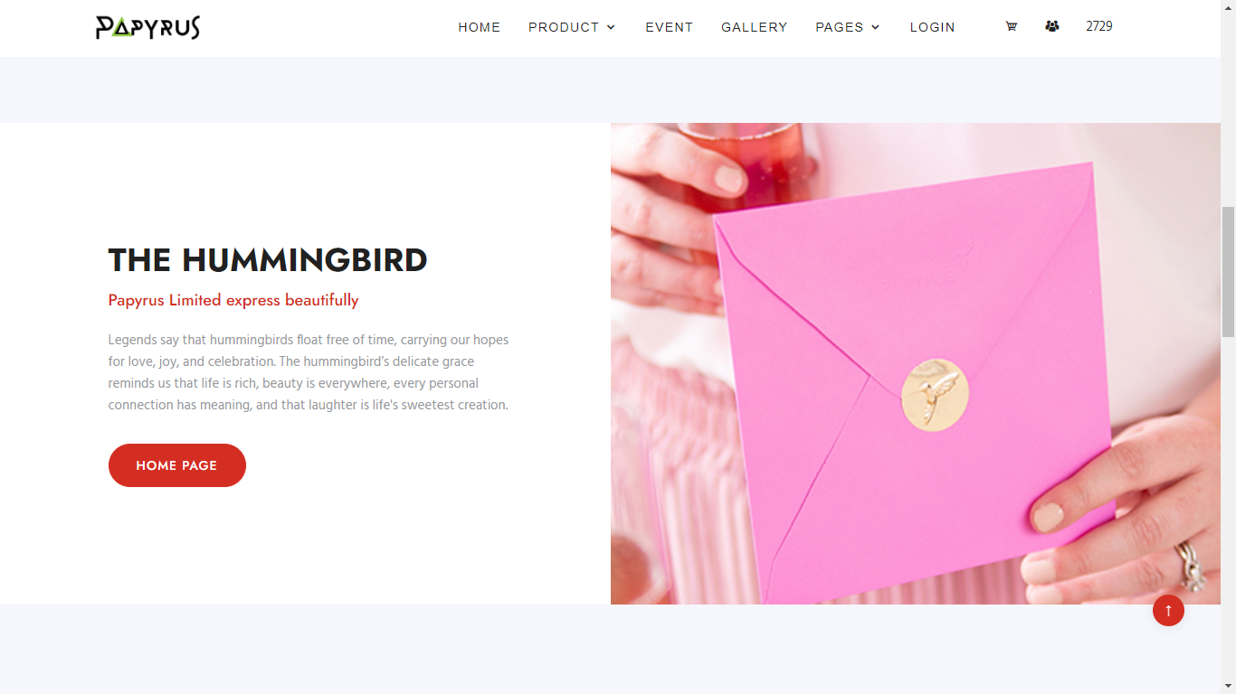

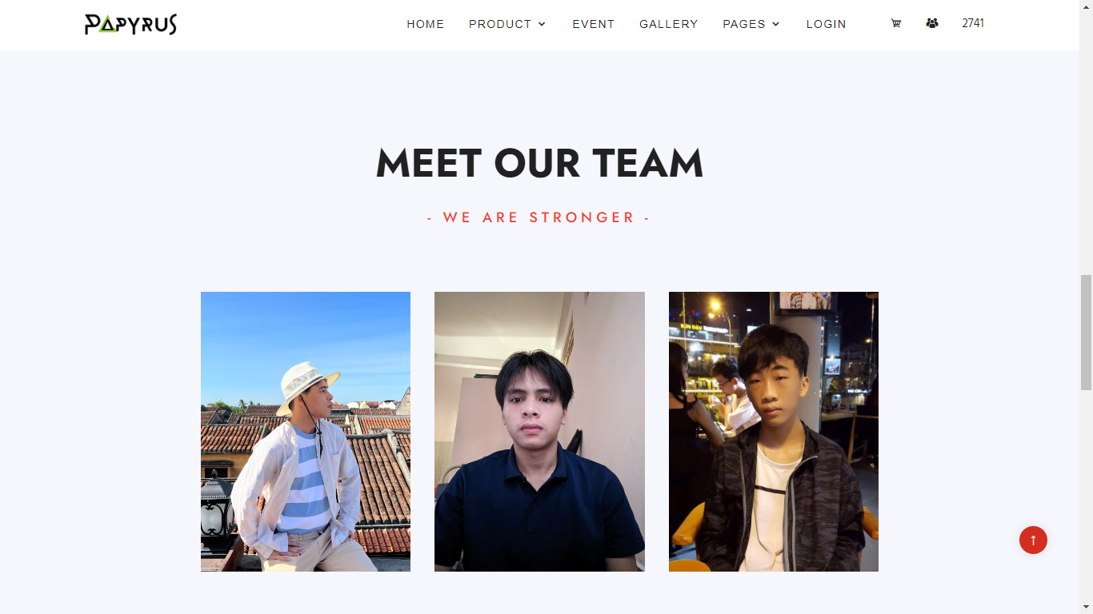

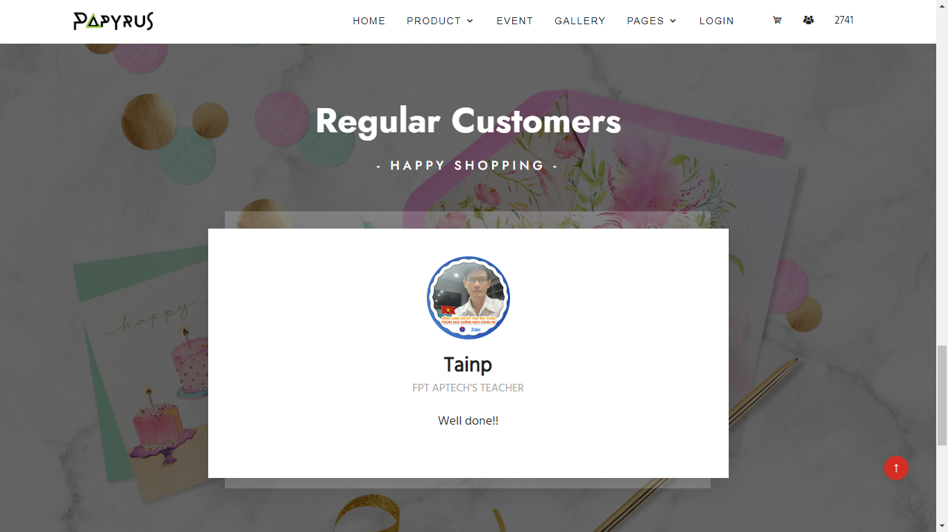

* 1. **Contact Page**
* Description: this page provides Name, Email, Phone number and one form for customer to fill what they want to feedback to the company. There is also a map for user to locate us.
* Sreenshot:

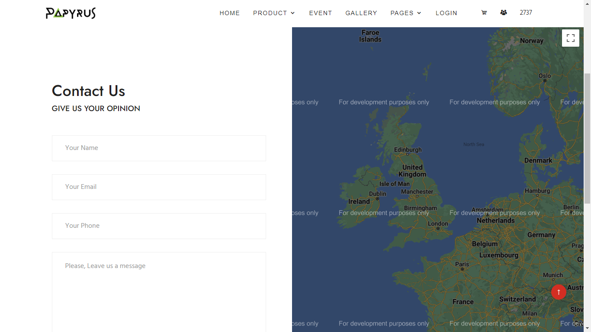

* 1. **Site Map****, Privacy Policy, Terms & Conditions, FAQs.**
* Description: these pages provide Site Map, , Privacy Policy, Terms & Conditions, Frequently Asked Questions for customer reference.
* Sreenshot:

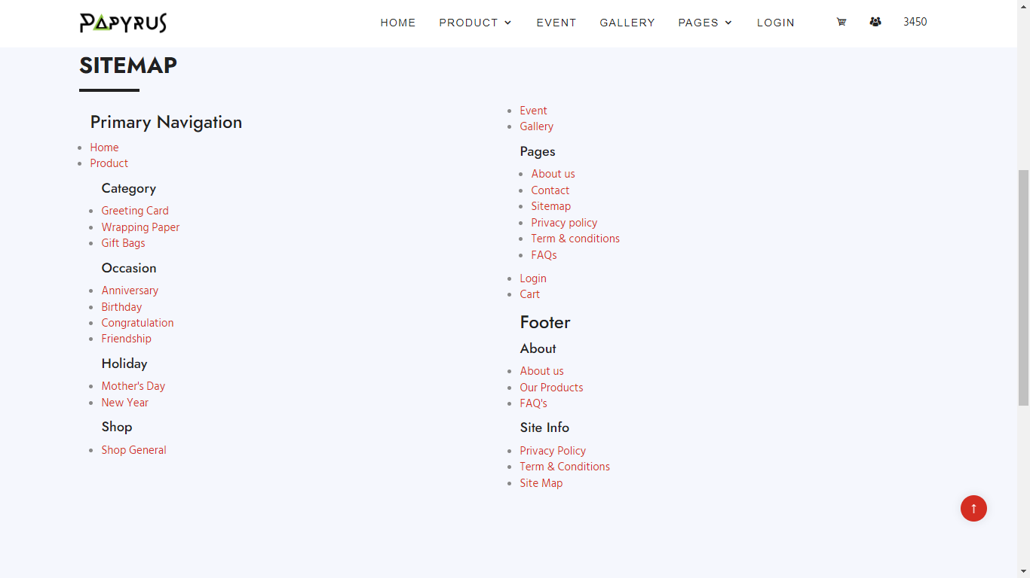

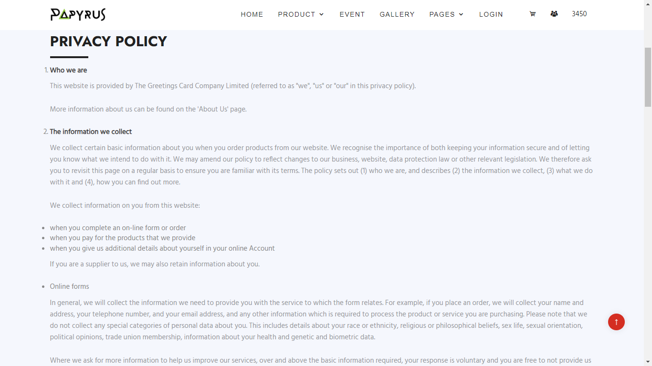

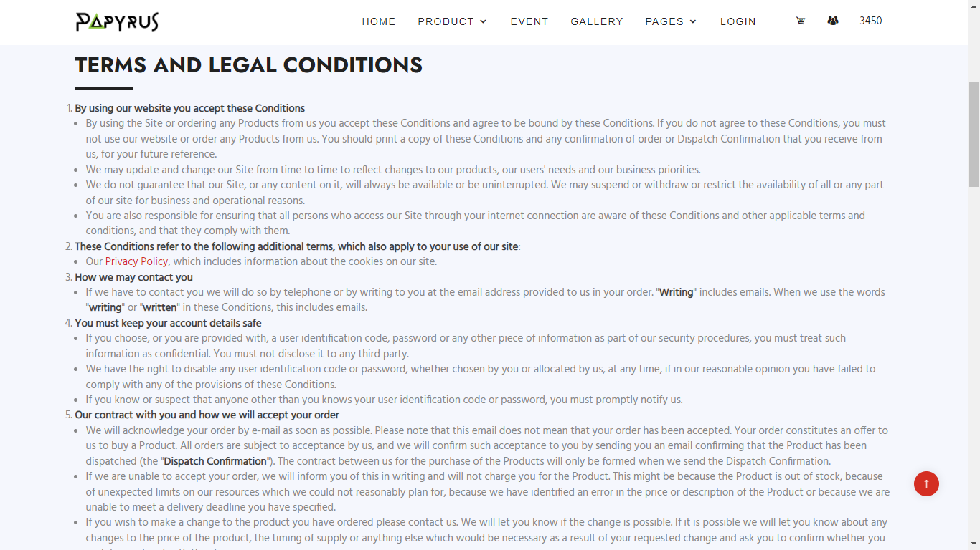

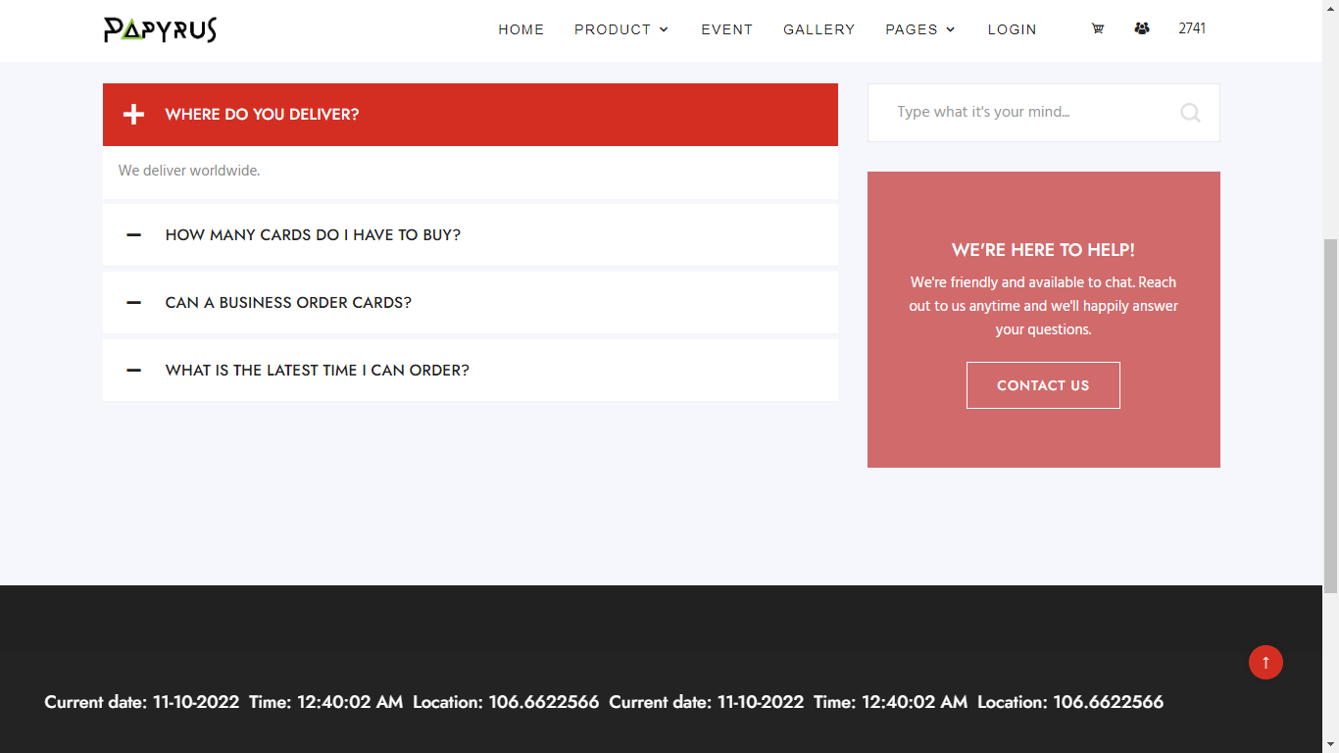

1. ***Log in***

* Description: This page allows users to log in to their account to enjoy the store's members-only offers. If you do not have an account, you can create your own through Create Account section.
* Screenshot:

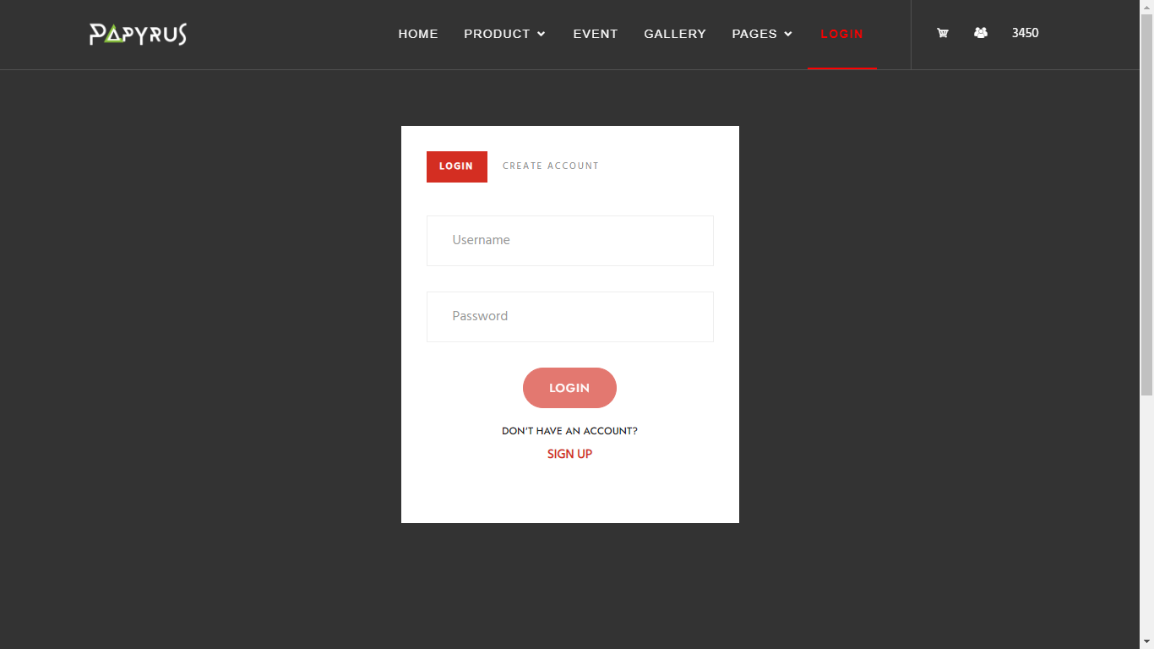

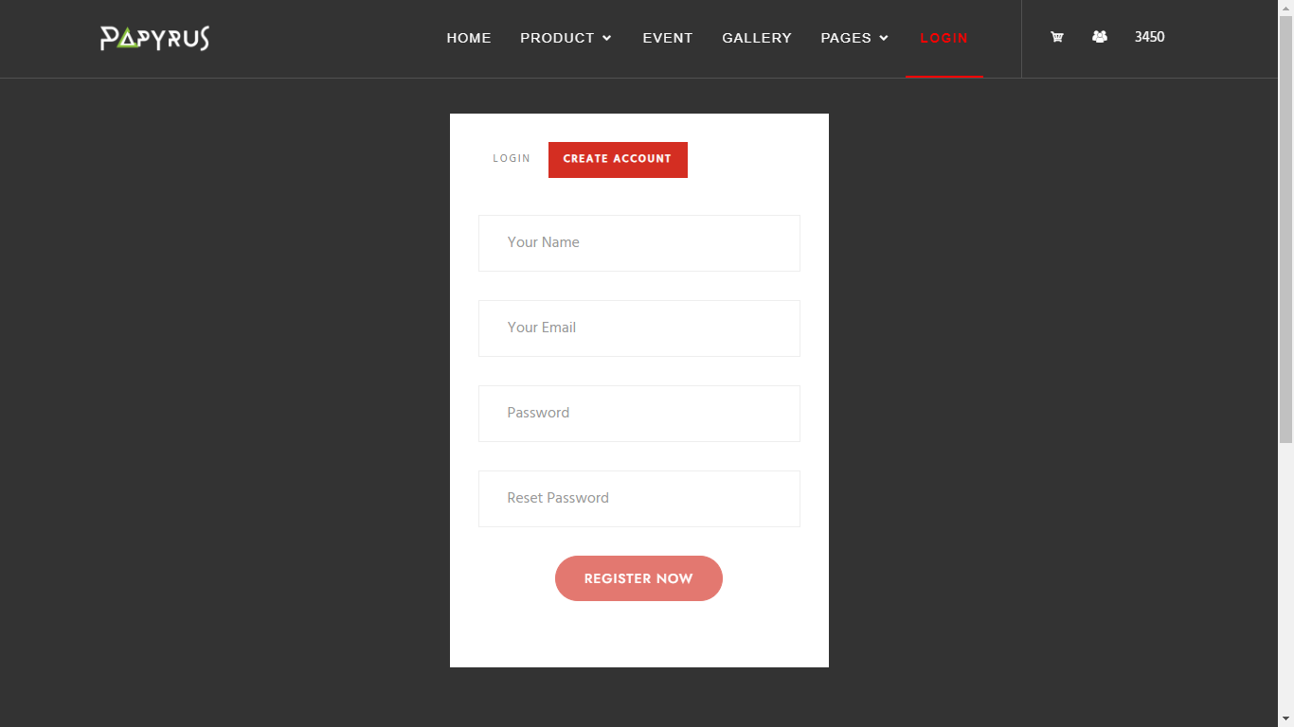

***Source Code HTML, CSS, JavaScript and AngularJS***

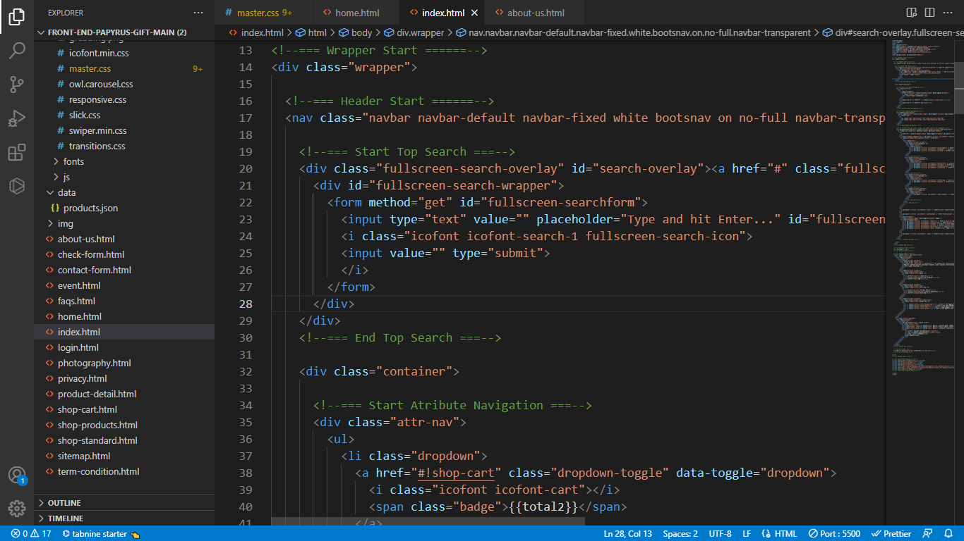

**Home page**

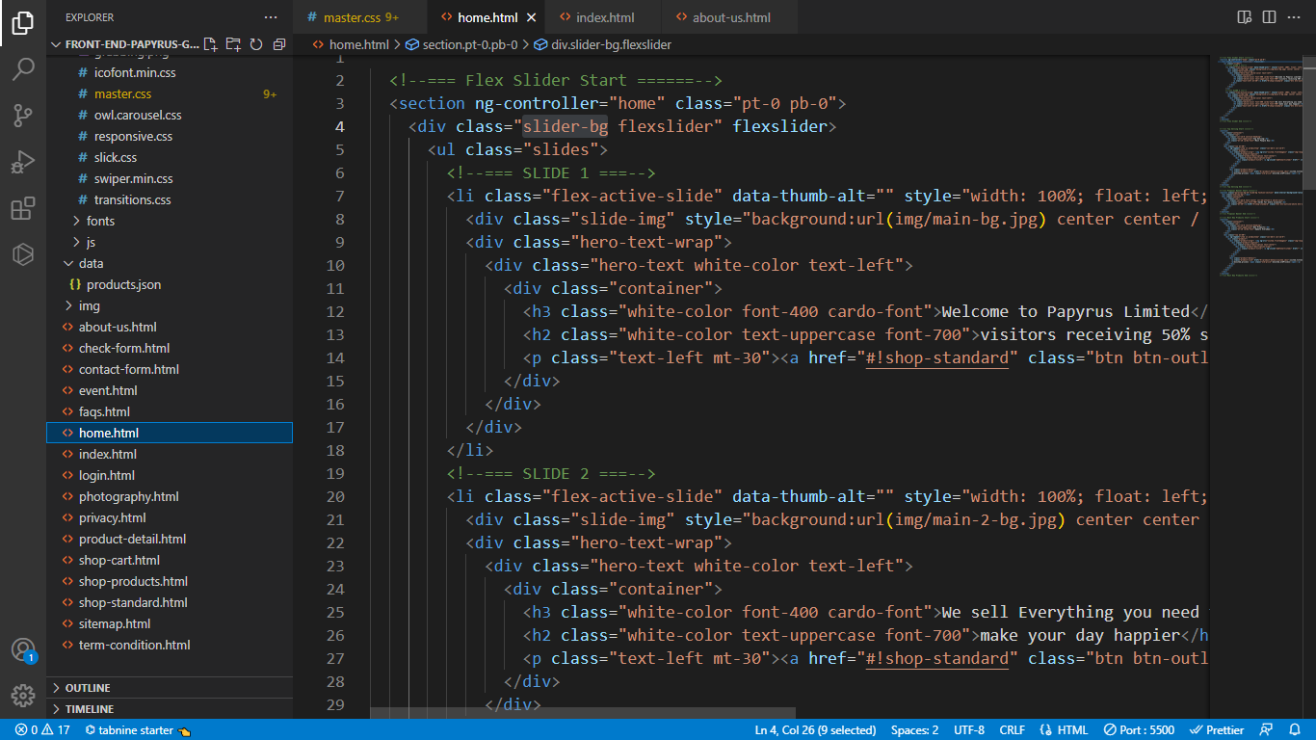

**Slideshow**

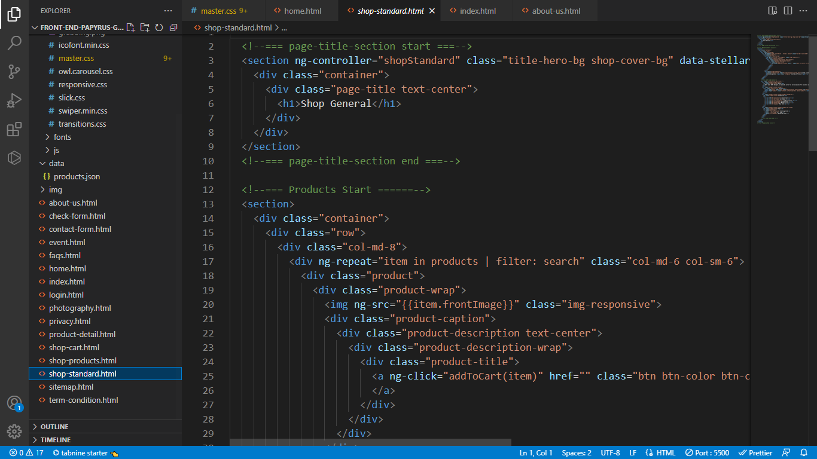

**Product page**

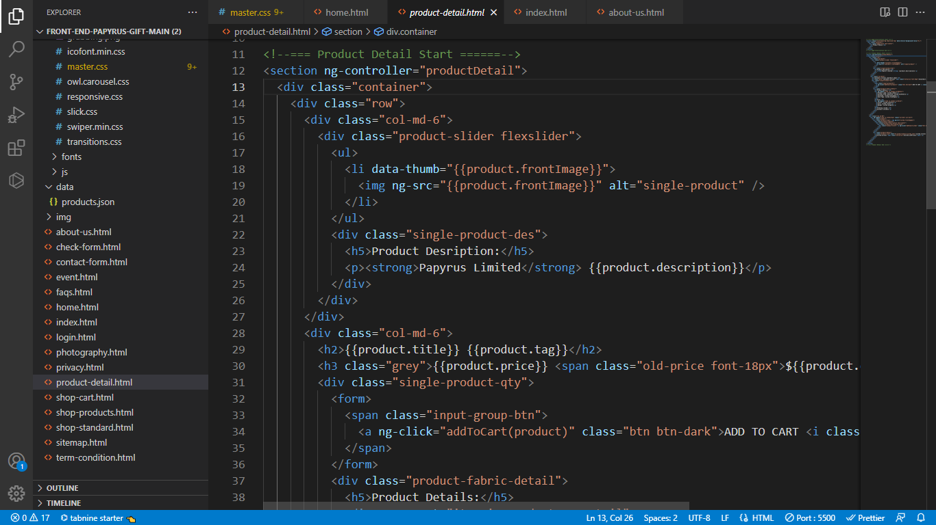

**Products detail page**

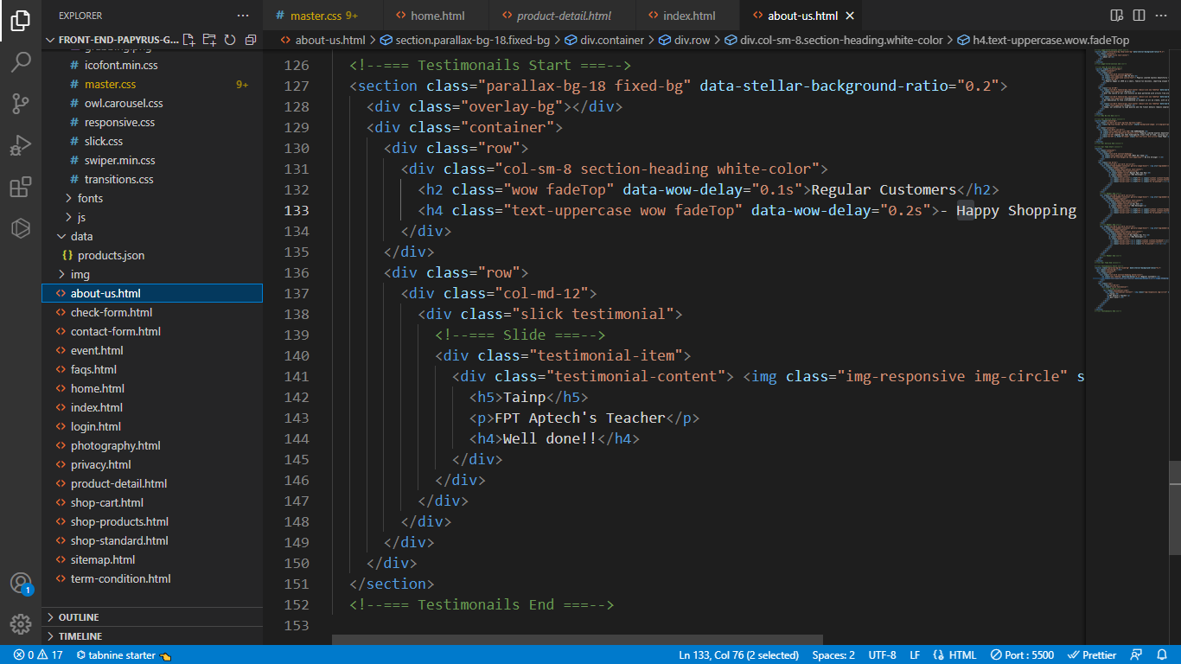

**About Us page**

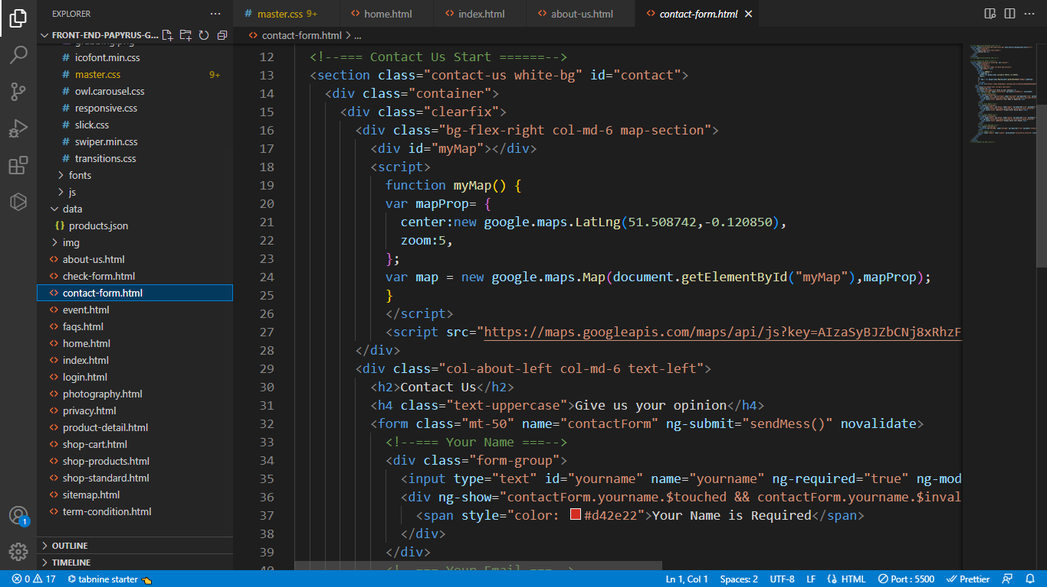

**Contact Us page**

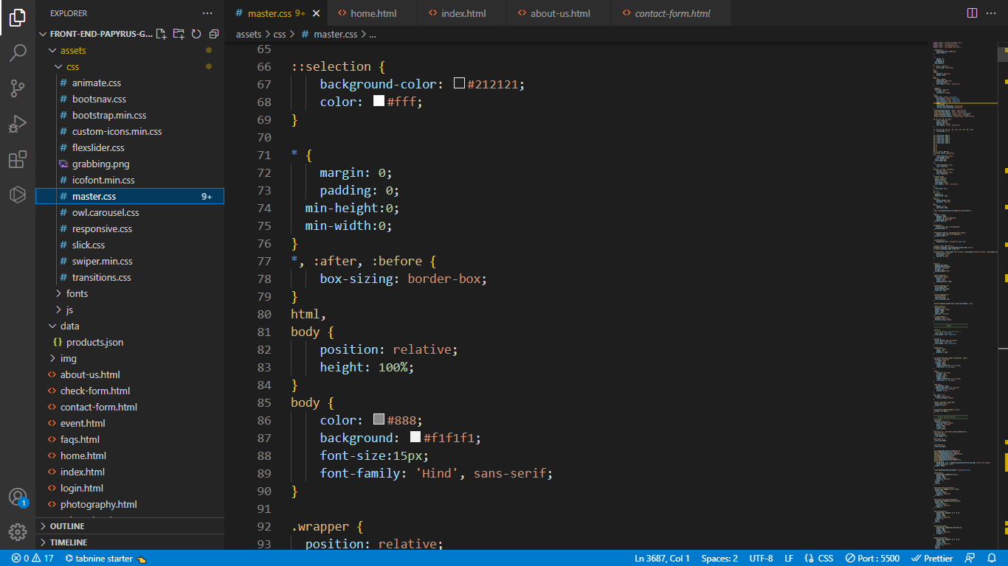

**master.css**

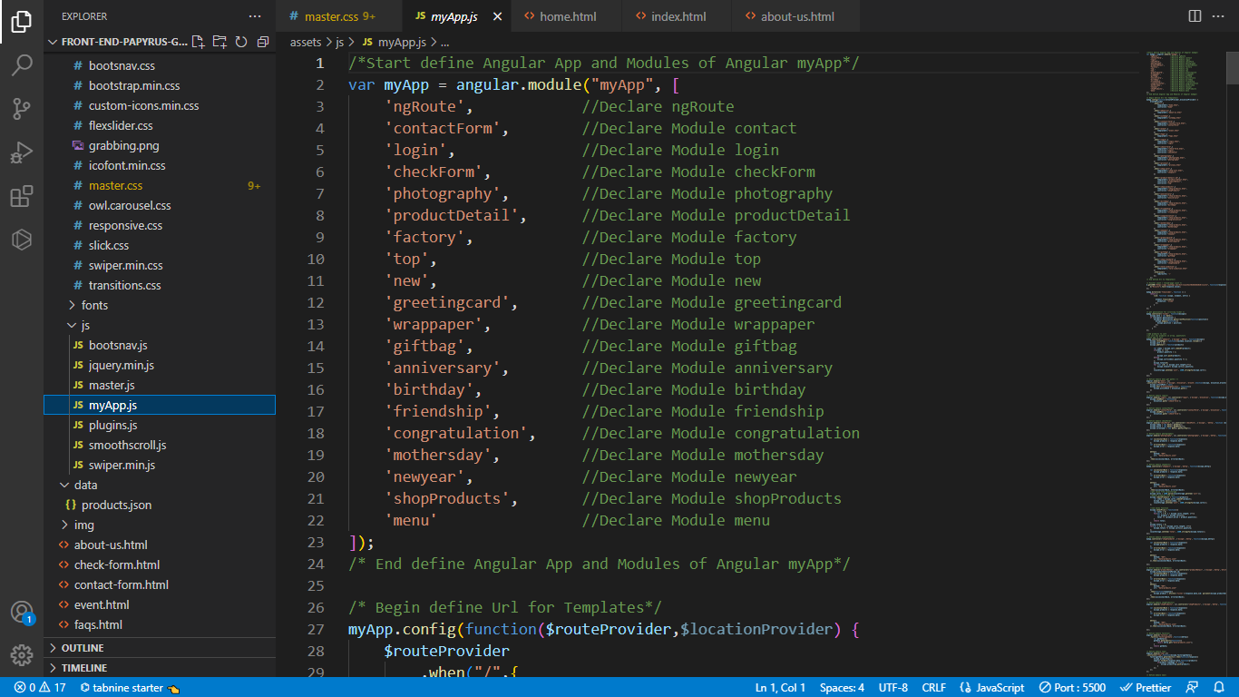

**app.js**

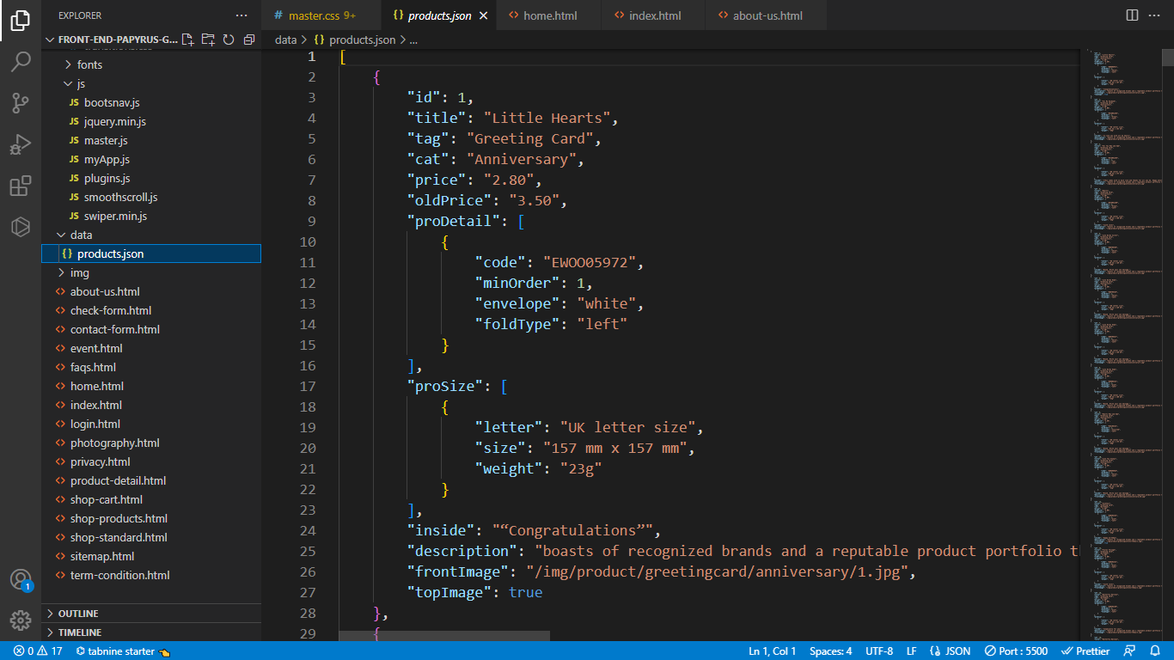

**json file**

***Task Sheet Review 3***

|  |  |  |  |  |  |  |  |
| --- | --- | --- | --- | --- | --- | --- | --- |
| **Project Ref. No.:**  **eP/Advertisement**  **Portal Management System/01** | | **Project Title:** | **Activity Plan Prepared By:** | **Date of Preparation of Activity Plan:** | | | |
| **Sr.**  **No.** | **Task** | **Actual**  **Start Date** | **Actual Days** | **Team**  **Mate Names** | **Status** |
| 1 | Home page | Papyrus Limited | Duy | 10-Oct-2022 | 1 | Duy, Trí, Anh | Completed |
| 2 | Product | 10-Oct-2022 | 1 | Duy, Trí, Anh | Completed |
| 3 | Event | 10-Oct-2022 | 1 | Duy, Trí, Anh | Completed |
| 4 | Gallery | 10-Oct-2022 | 1 | Duy, Trí, Anh | Completed |
| 5 | Contact us | 10-Oct-2022 | 1 | Duy, Trí, Anh | Completed |
| 6 | About us, Siter Map | 10-Oct-2022 | 1 | Duy, Trí, Anh | Completed |
| 7 | Json | 10-Oct-2022 | 1 | Duy, Trí, Anh | Completed |
| 8 | Live show | 10-Oct-2022 | 1 | Duy, Trí, Anh | Completed |
| 9 | Task sheet | 10-Oct-2022 | 1 | Duy, Trí, Anh | Completed |

|  |  |
| --- | --- |
| **Date: 10 – Oct – 2022** | |
| Signature of Instructor:  **Mr. Nguyen Phat Tai** | Signature of Team Leader:  **Mr. Nguyen Ngoc Bao Duy** |